JAVASCRIPT

* SINGLE THREADED CONCURRENT PROGRAMMING LANGUAGE
* OBJECT ORIENTED LANGUAGE

SINGLE THREAD -ONLY ONE OPERATION AT A TIME

IT IS AN INTREPRETER EXCETUTED ONLY ONE LINE AT A TIME

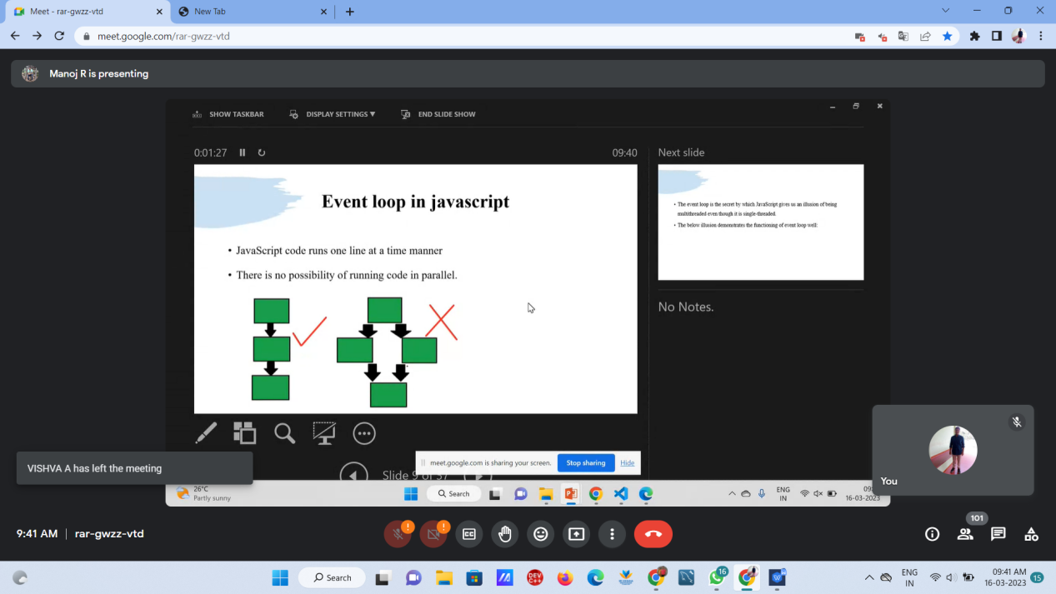

DATATYES OF JS

1. NUMERIC
2. BOOLEAN
3. STRING

PRINT MEHODS

1. CONSOLE.LOG
2. DOCUMENT.WRITE()
3. ALERT-POP UP MESSAGE

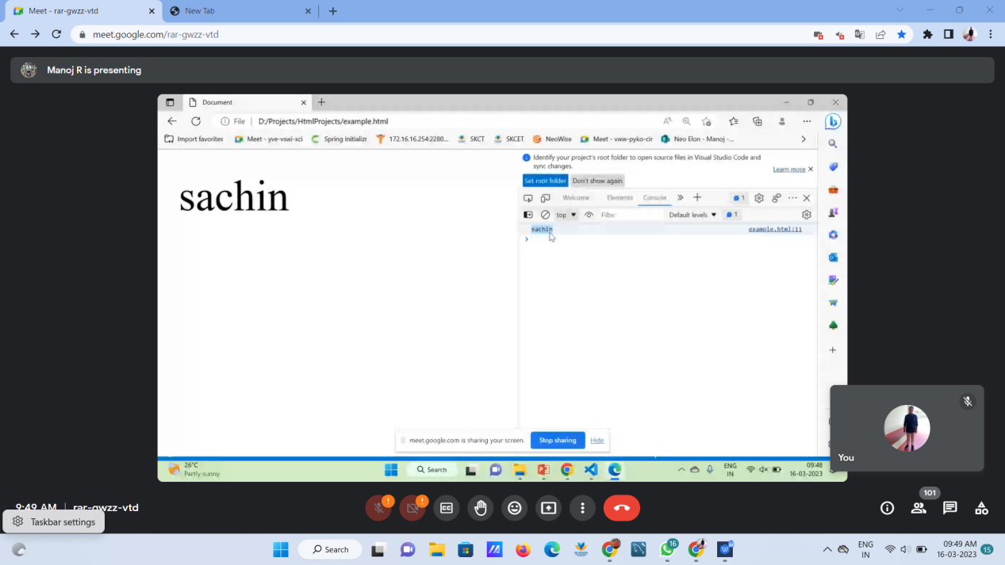

1.var

Whenever we use var with variable we can re declare the the variable

Only can be used inside declared function

1. Let

Whenever we use let we cannot re declare the variable.let is said to as a block scope

1. Const

Whenever we use const we need to give value at the time of declaration.we cannot change value;

# Function

1. use function keyword

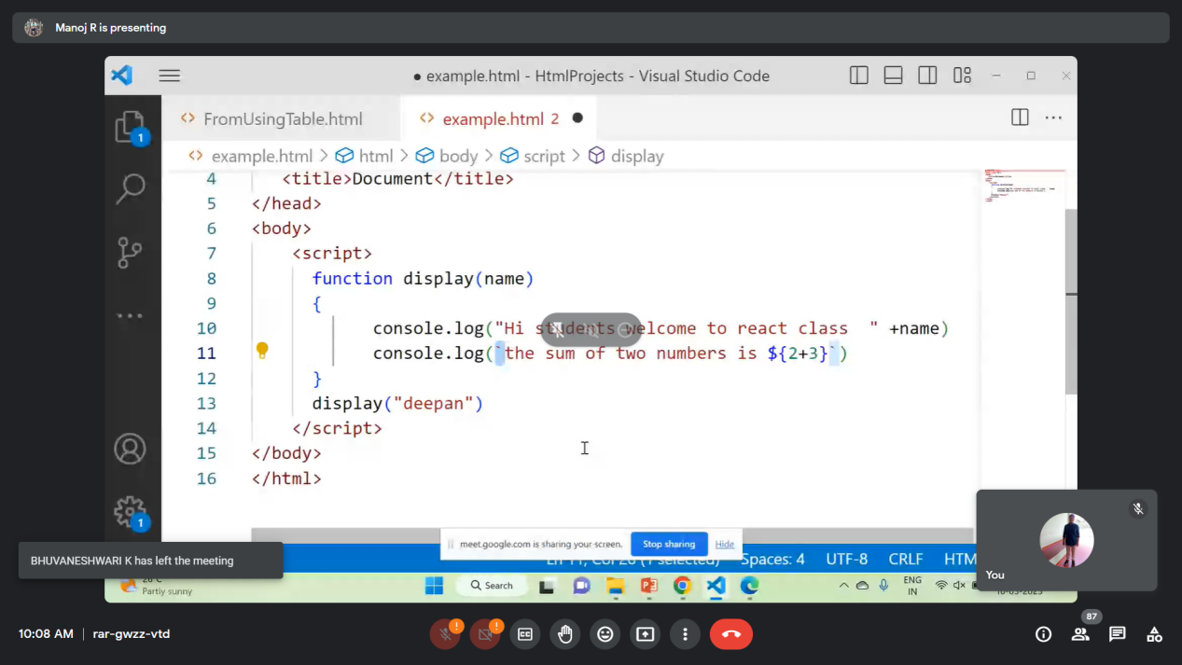

To perform operation in js use ` symbol;

Function declaring

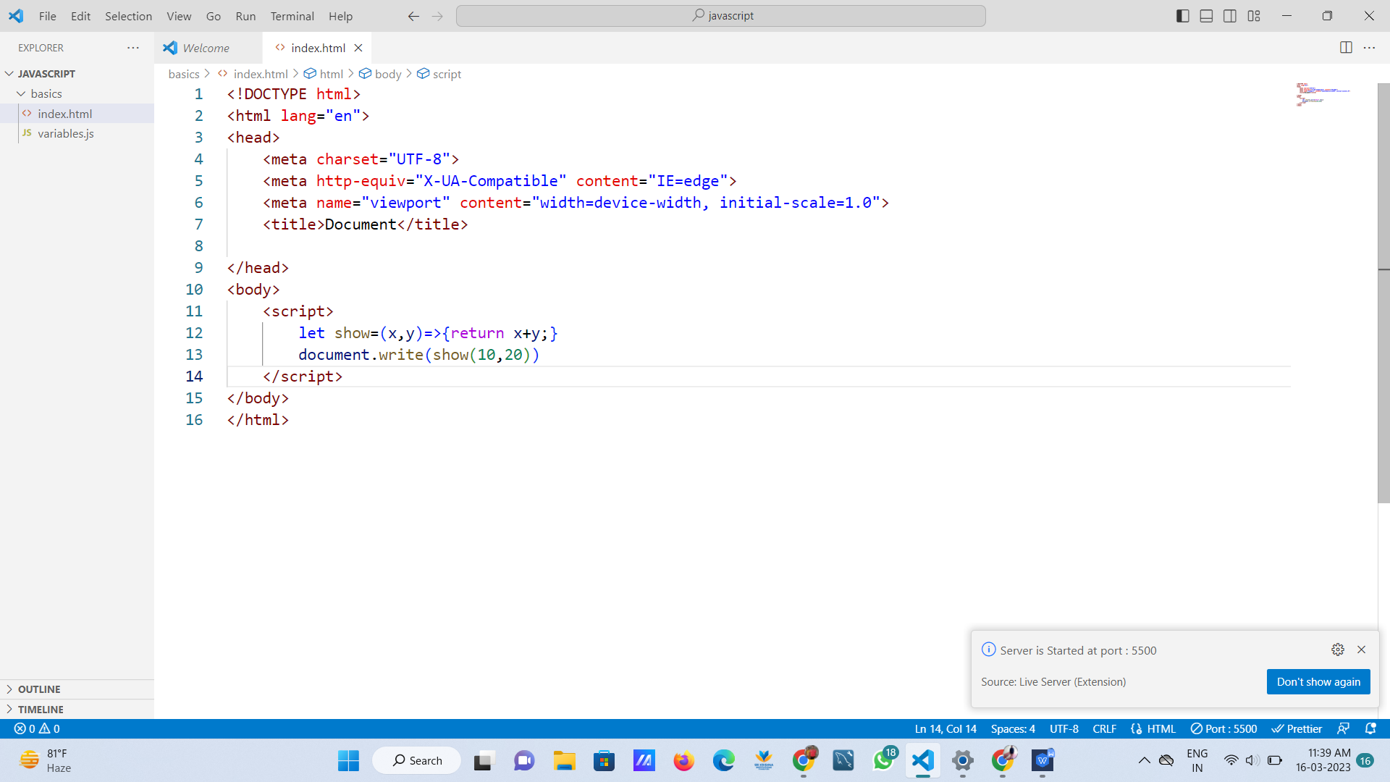

If else in js

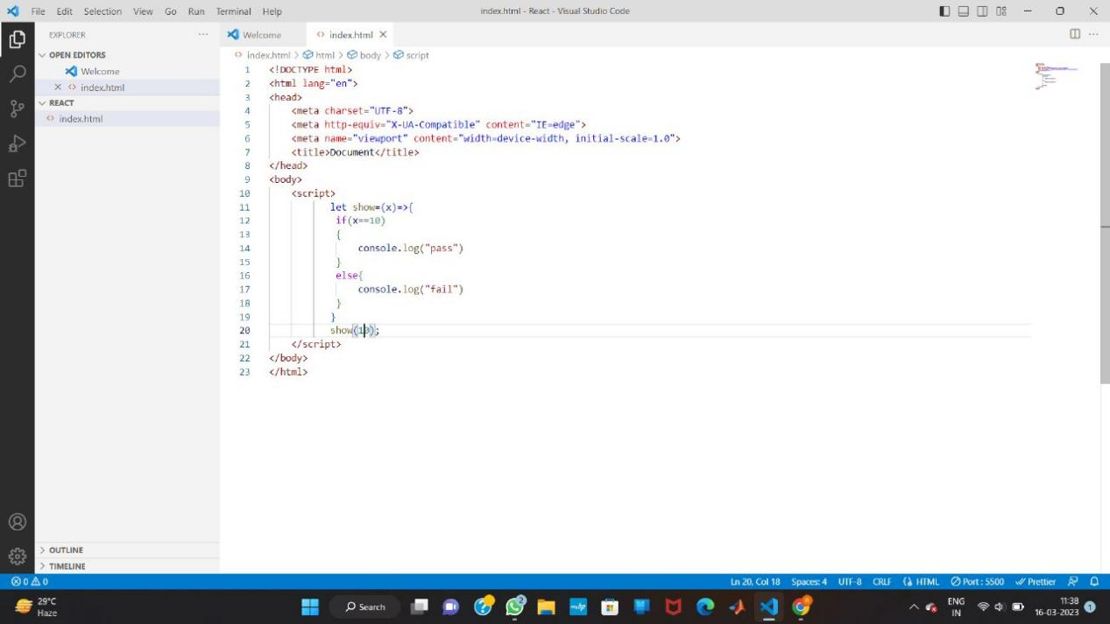

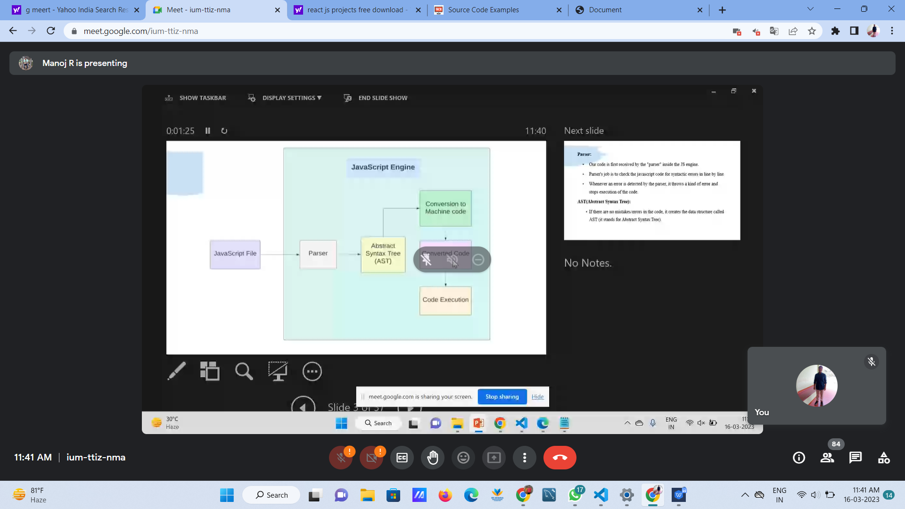

Parser-checks error

Abstract syntax tree

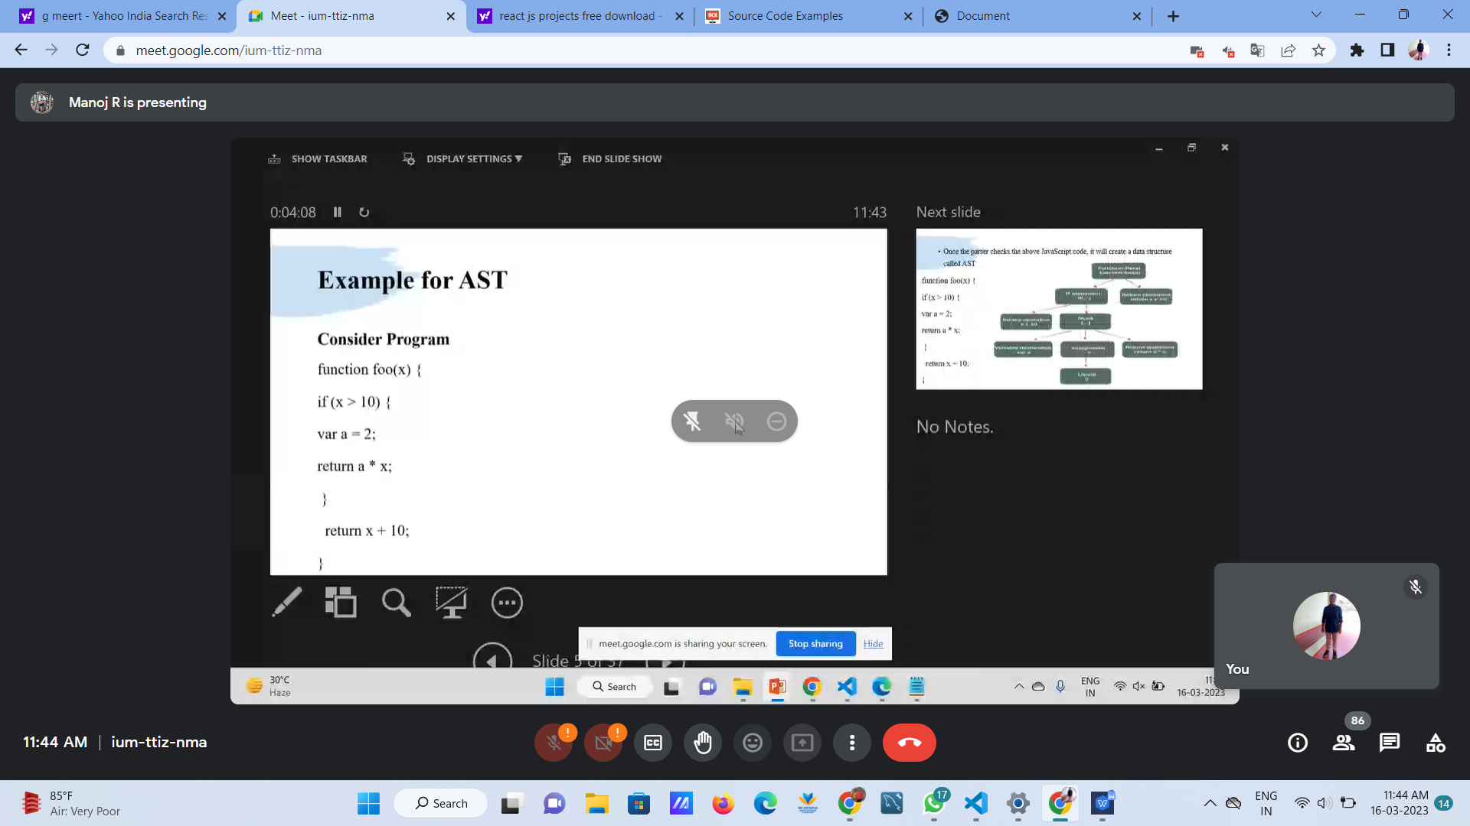

After ast

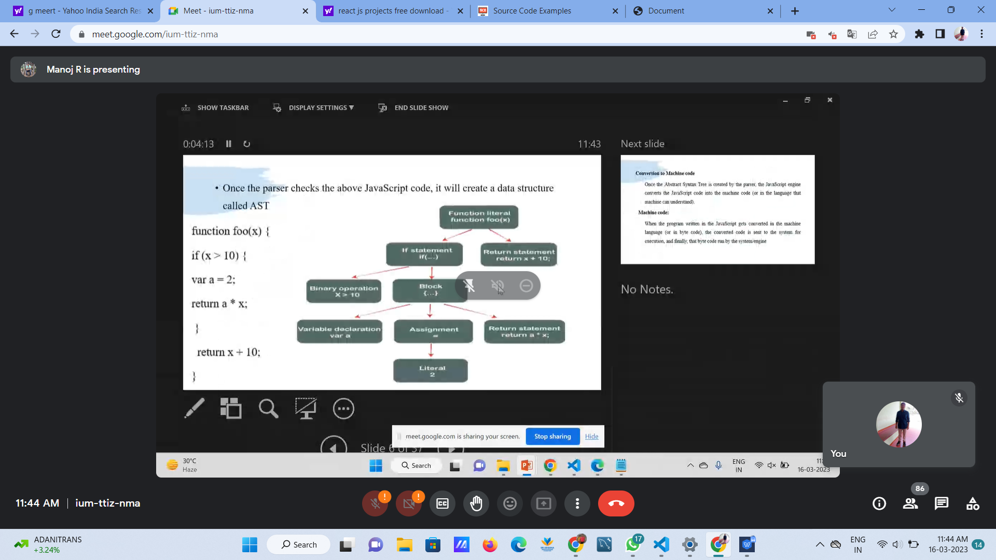

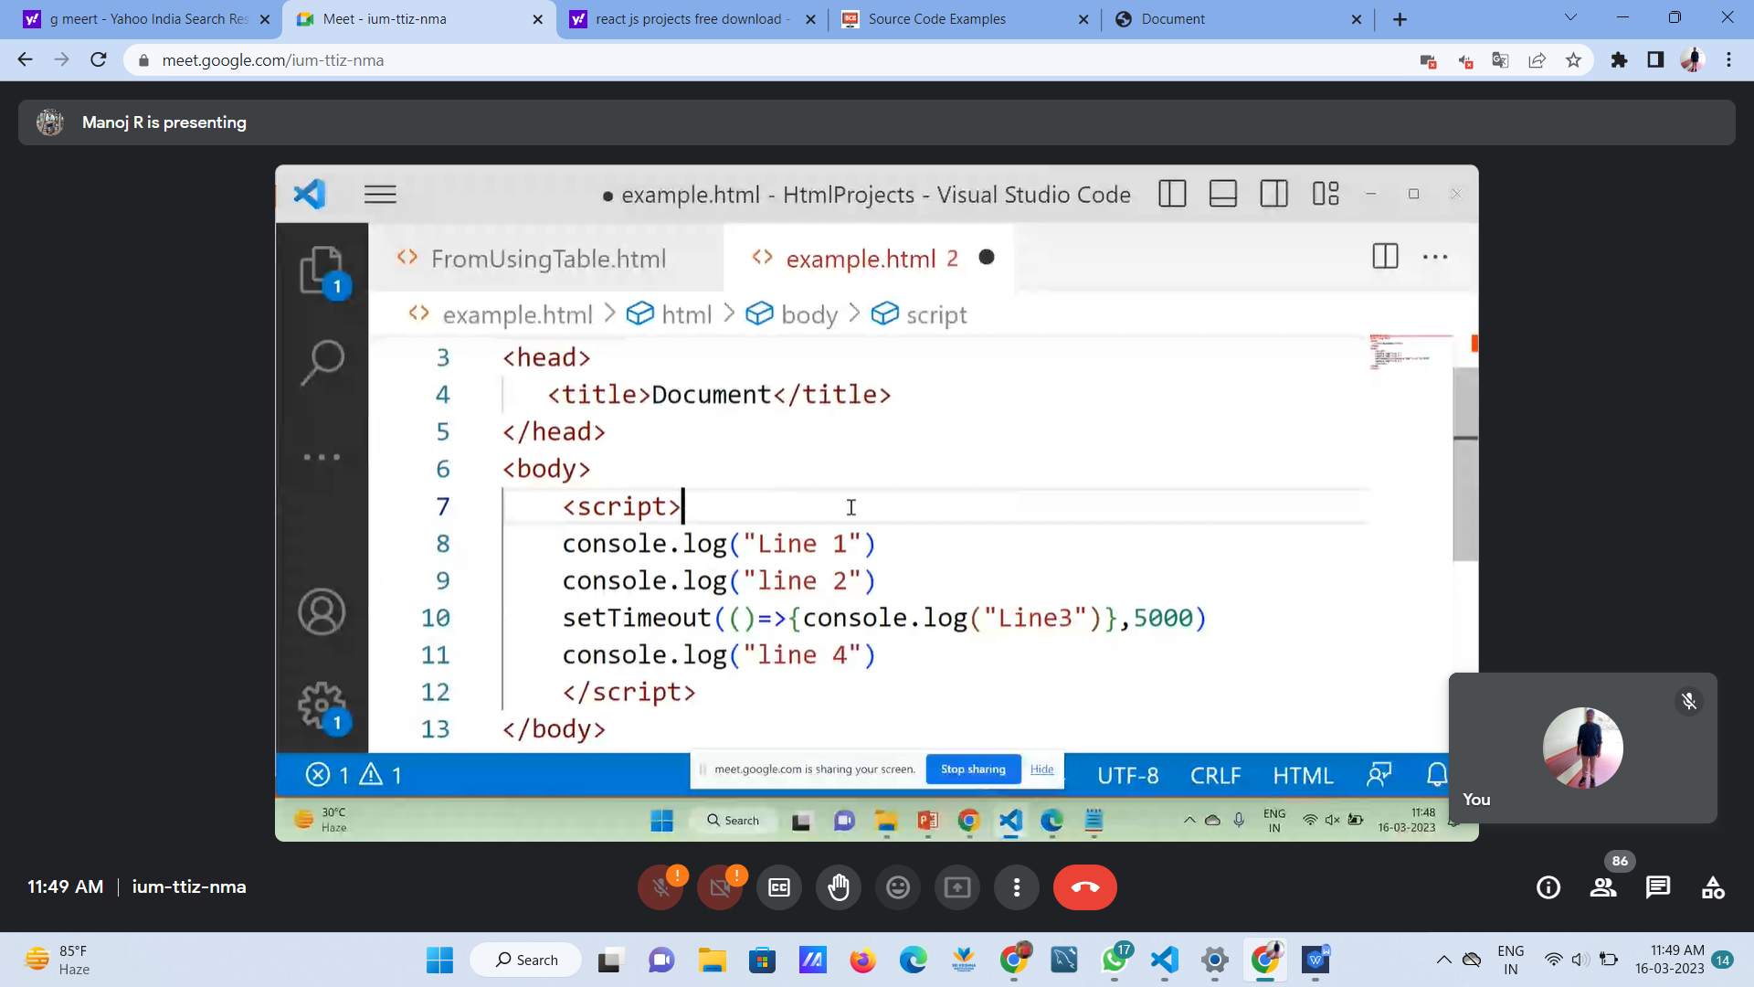

setTimeout-prints message after 5 sec

Synchronous -one single flow

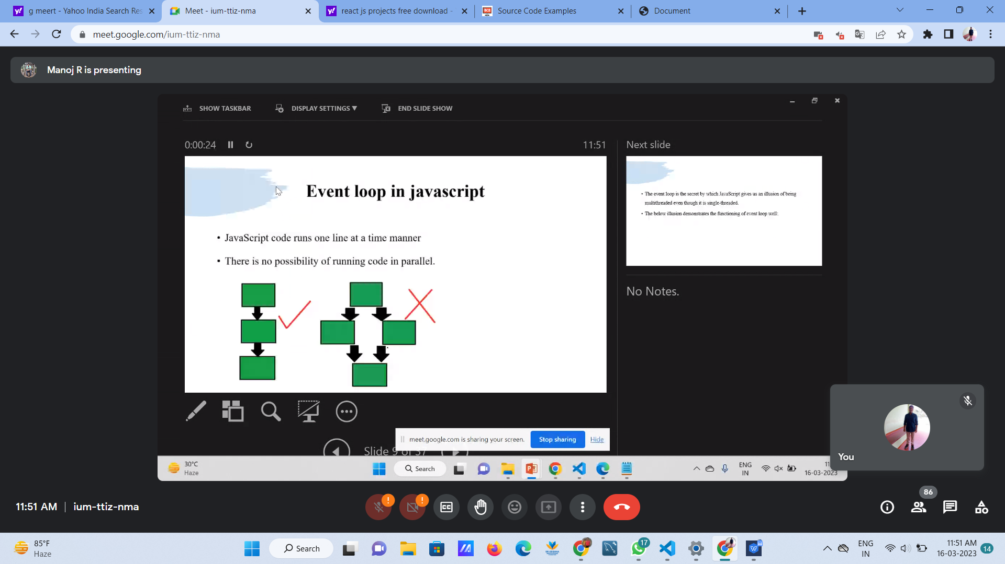

Stack

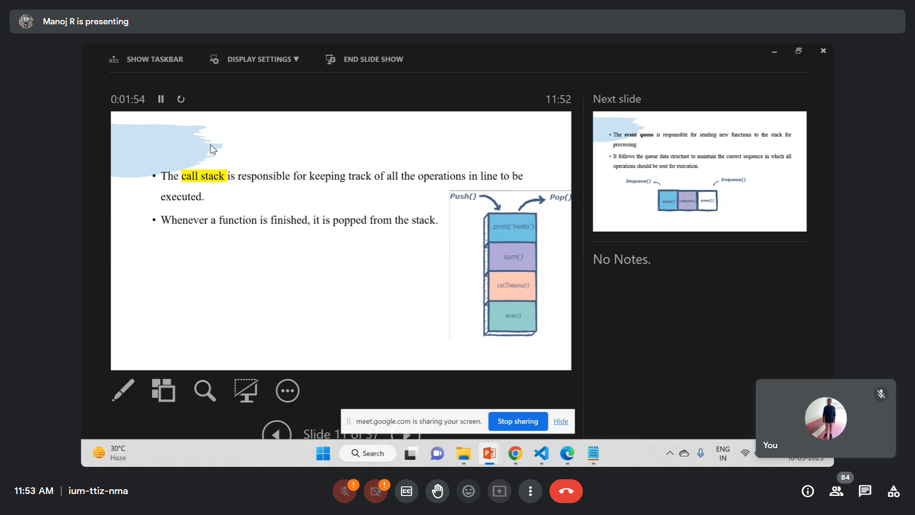

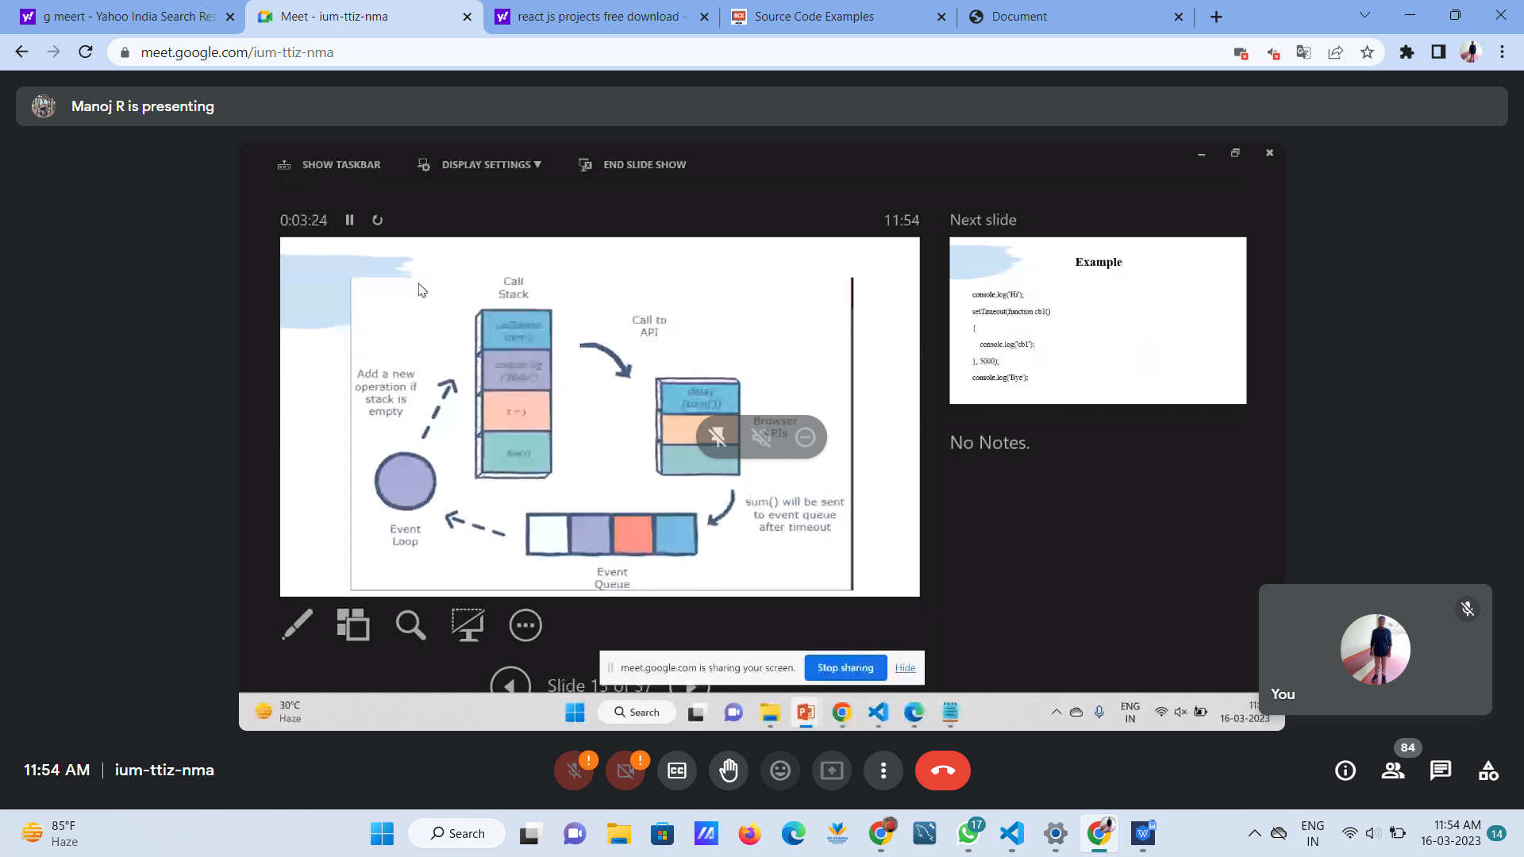

Process

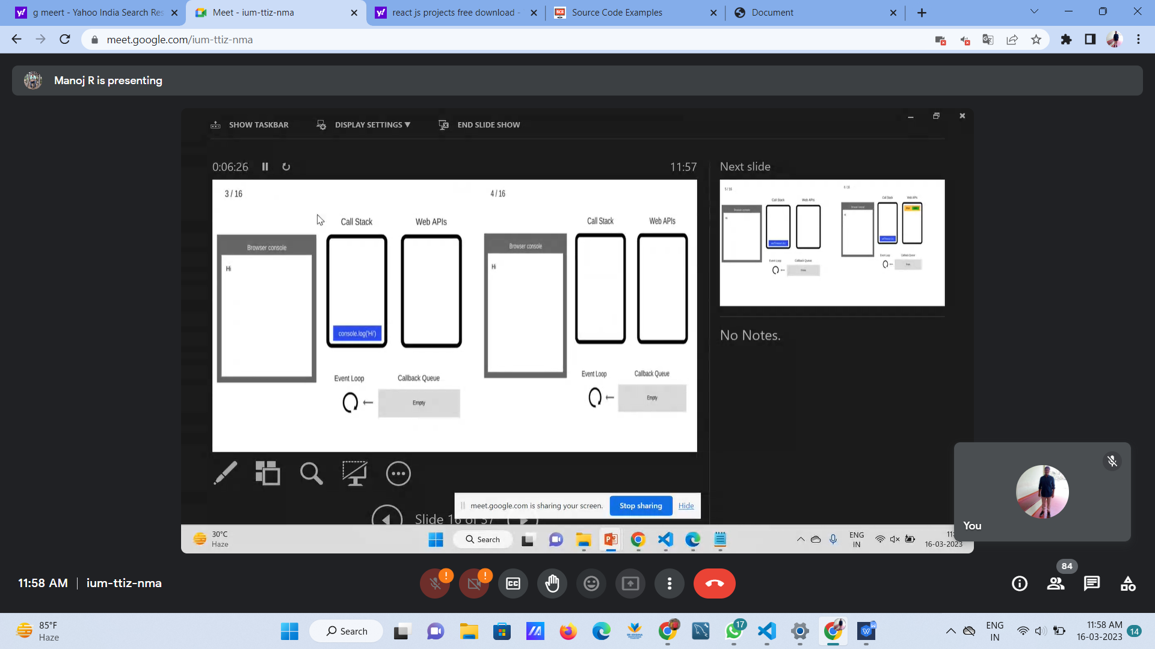

# NODE JS

#### node js is used to run js programs in browers

1. It is a cross operating software where it can be used in multiple os

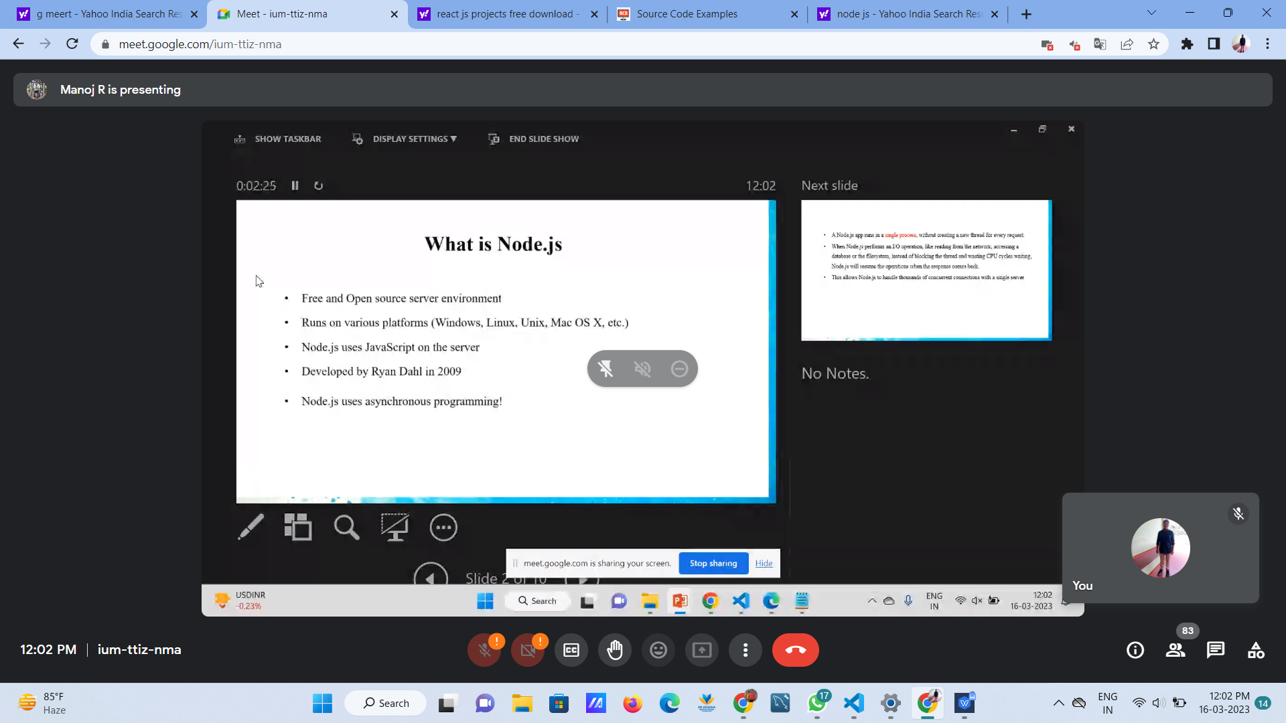

## Why we are using node:

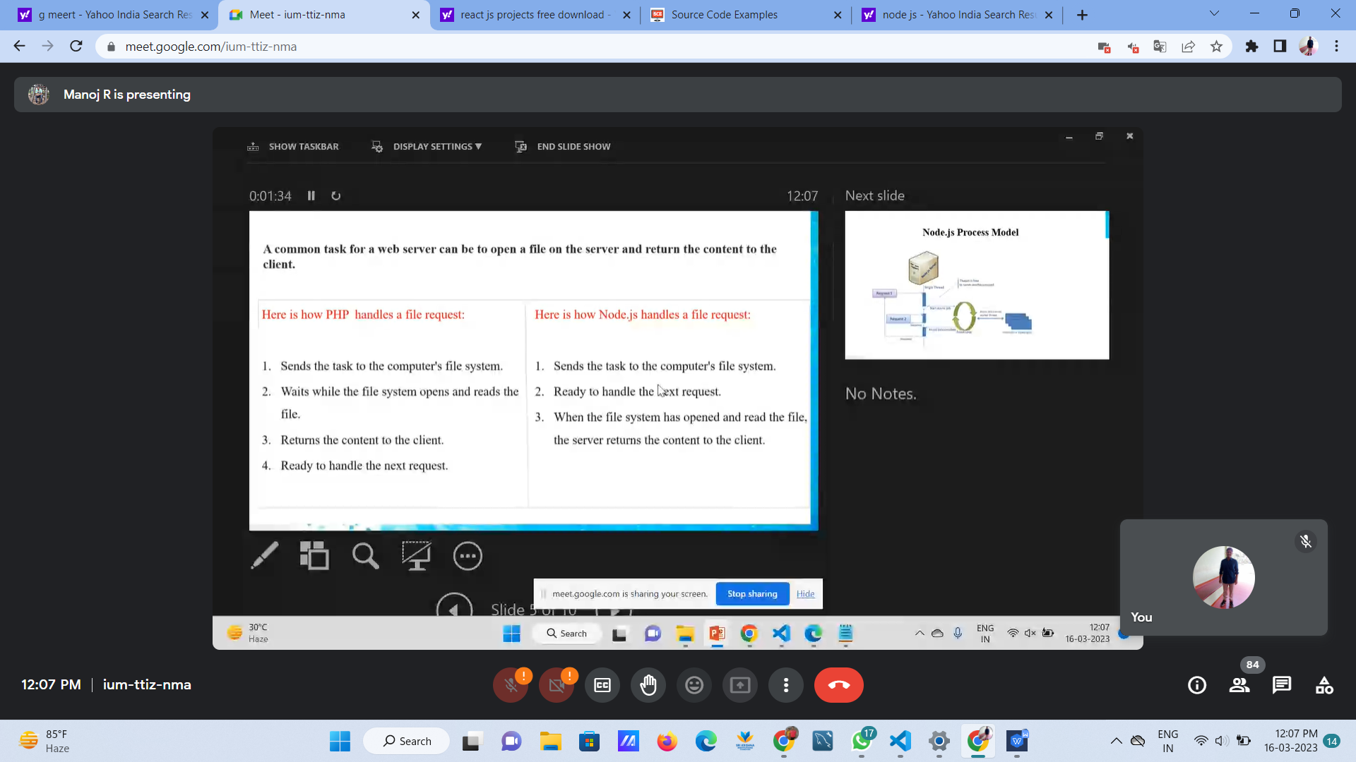

### WhatsApp Image 2023-03-16 at 12.11.56

# REACT JS

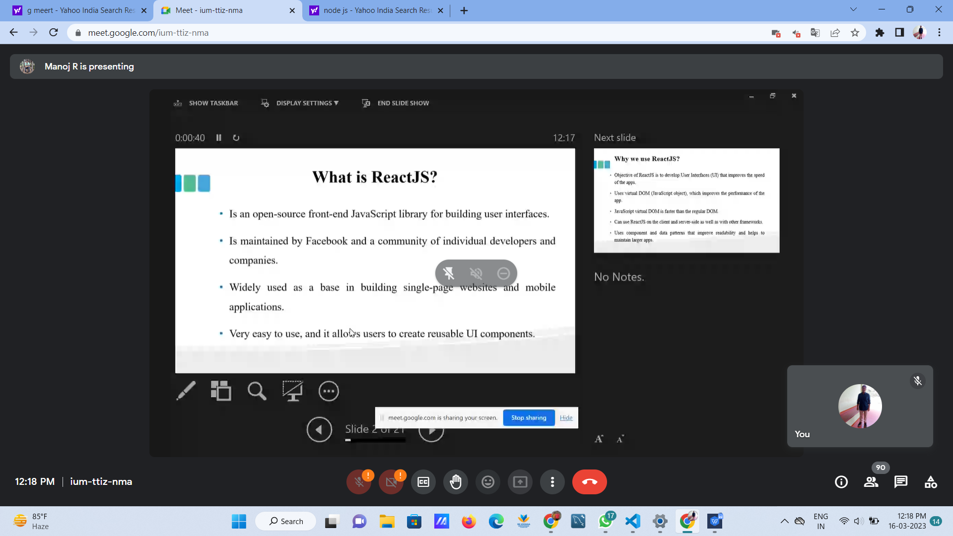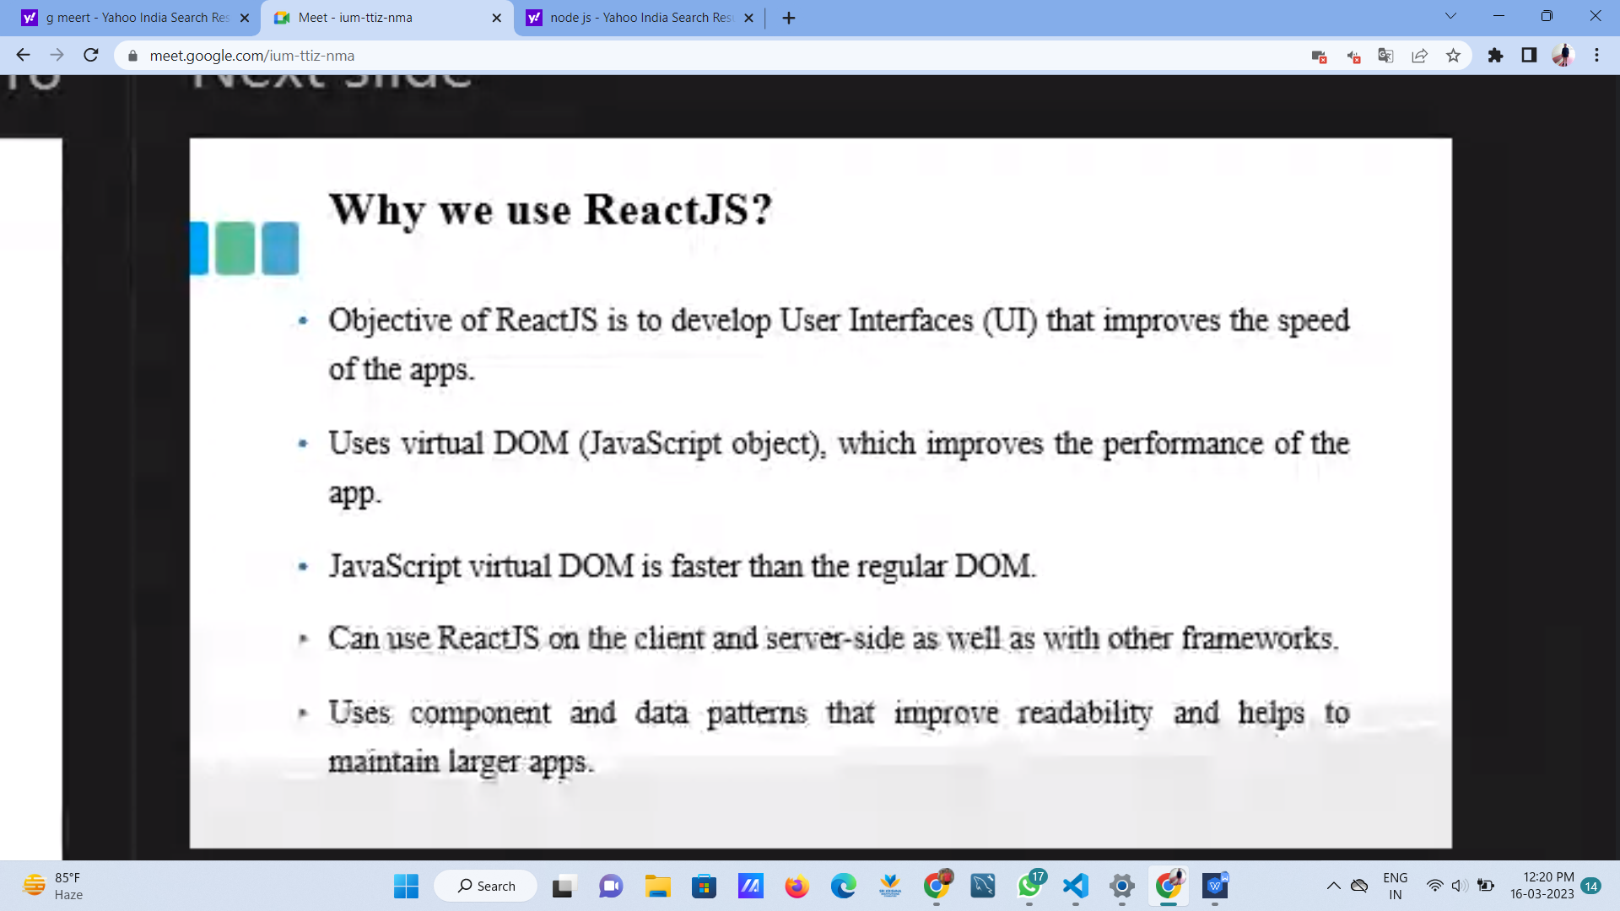

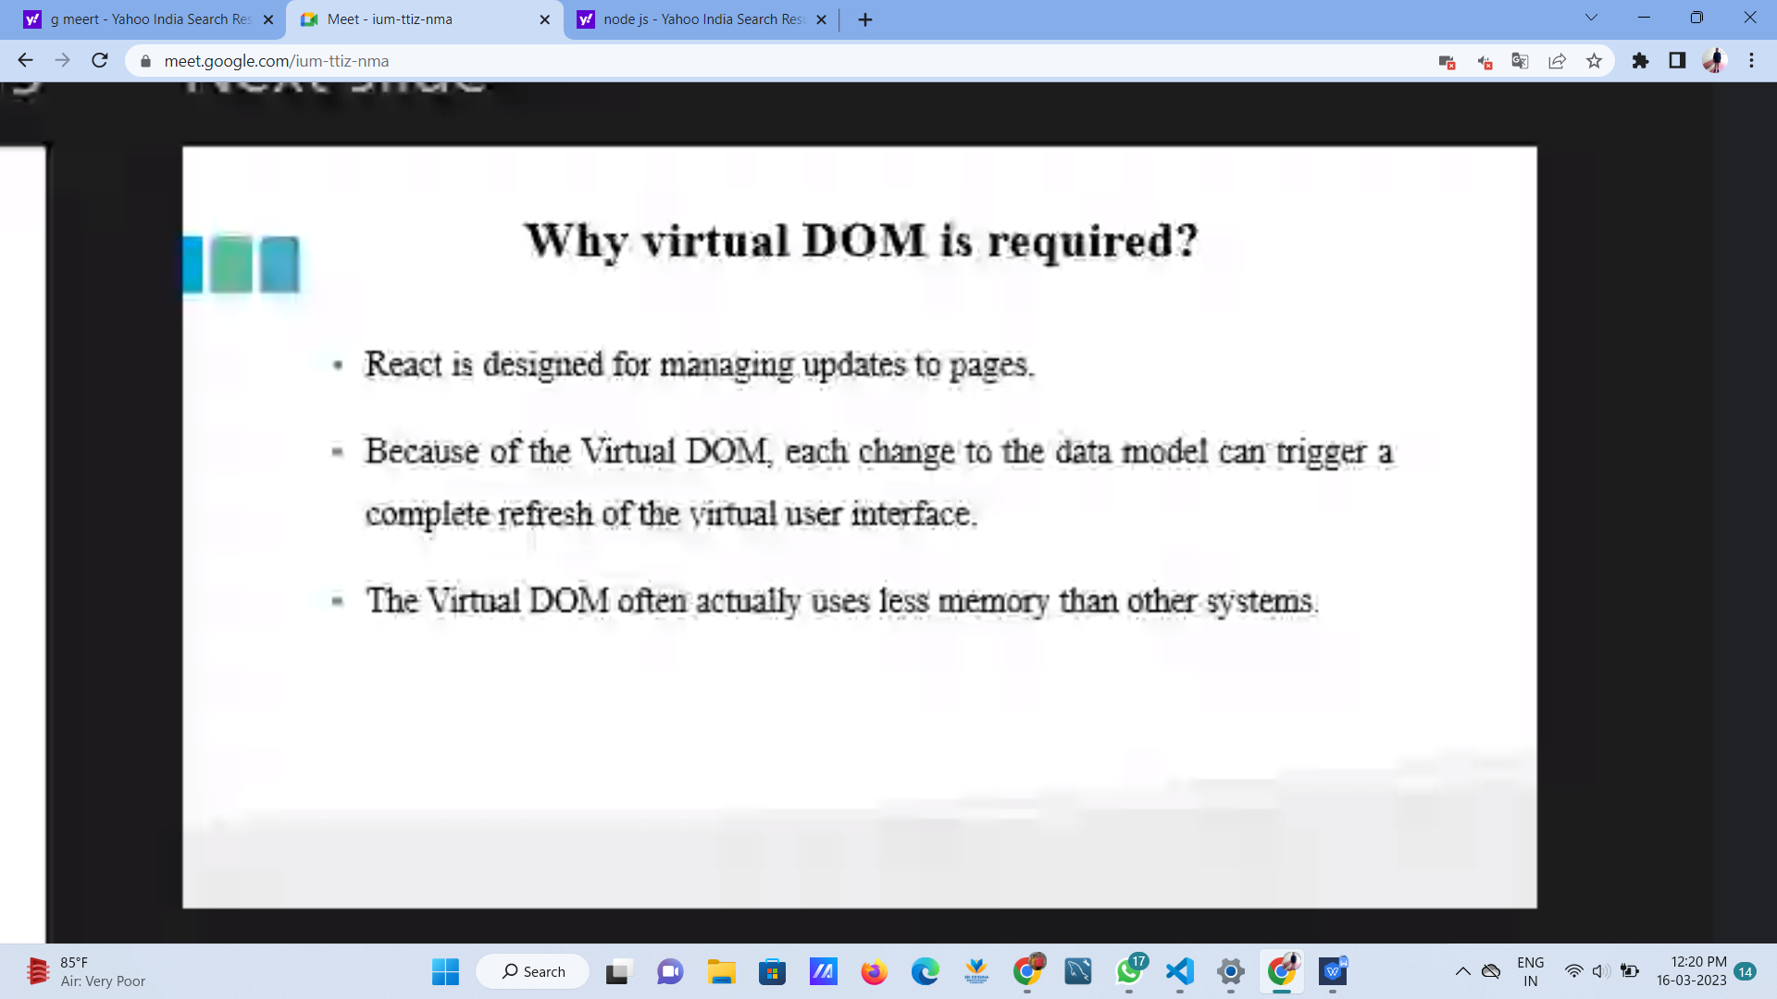

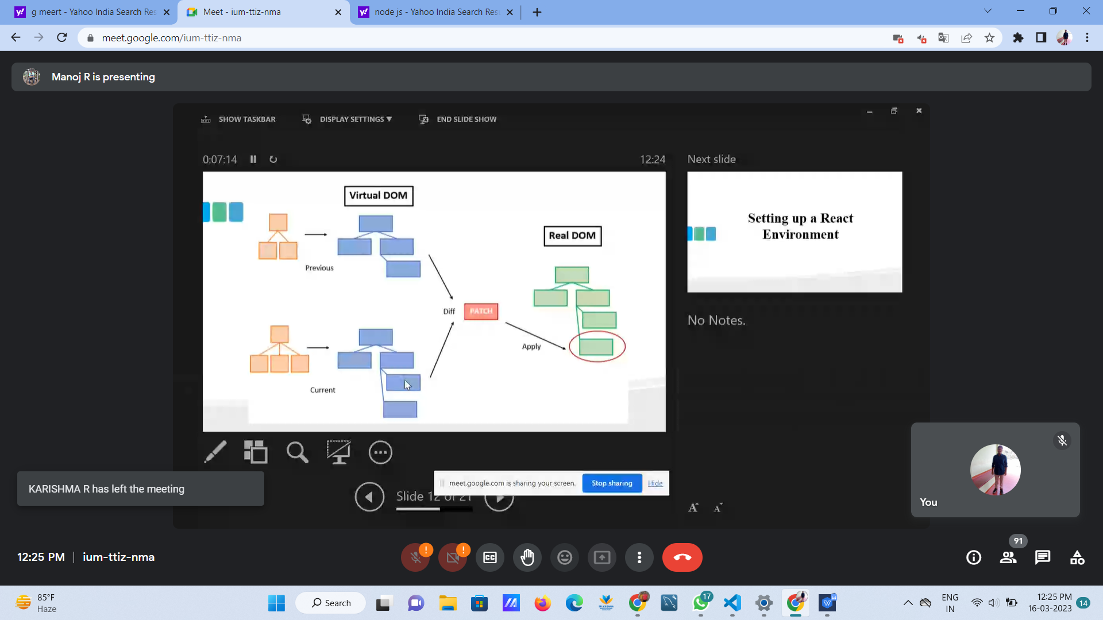

VIRTUAL DOM-

INSTEAD OF CREATING WHOLE DOM IT LOOKS FOR ANY CHANGES IN CURRENT DOM

**BABEL**

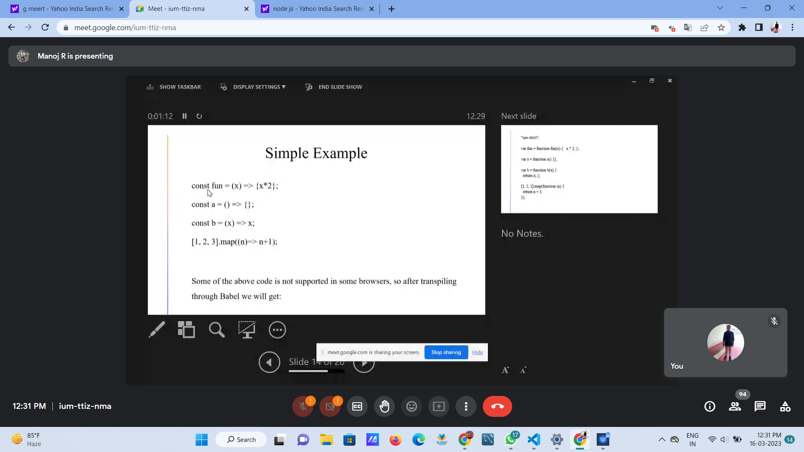

BABEL IS A TRANSPILER

WHICH CONVERTS LATEST JS INTO ONE THAT BROWSER UNDESTANDS

